User Actions

- Sign up

- Login

- Forgot password

- Modify user profile

- Search for books
User can search for books by title, language, author, publisher, publish date, subject, content, tagged species and regional affiliation.

- Sort books
User can sort books by three options: rate, title, number of views.

- Save search query
User can save his search query for future use.
Steps
- user should login first
- visit browse all page
- search for books by any search option (e.g: book title)
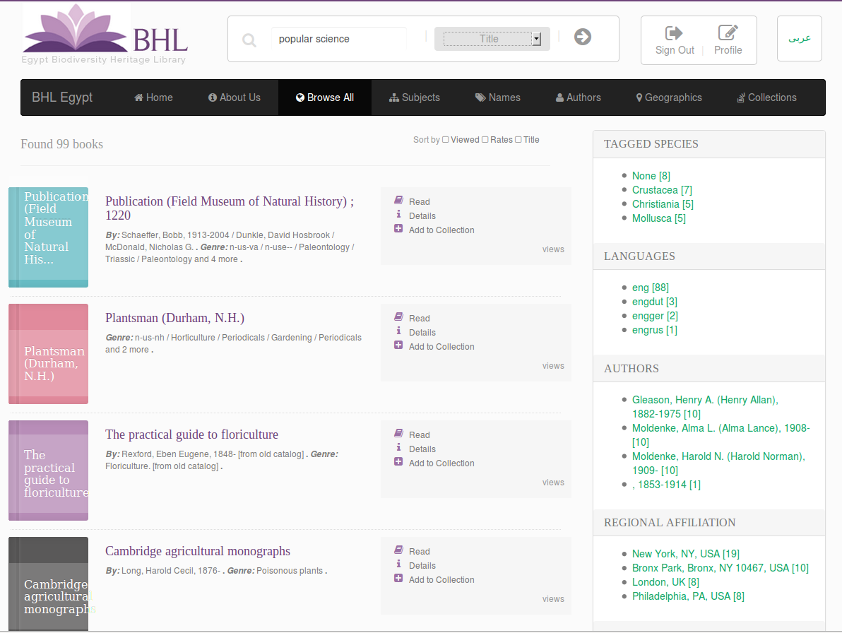
- after result returned click save query button
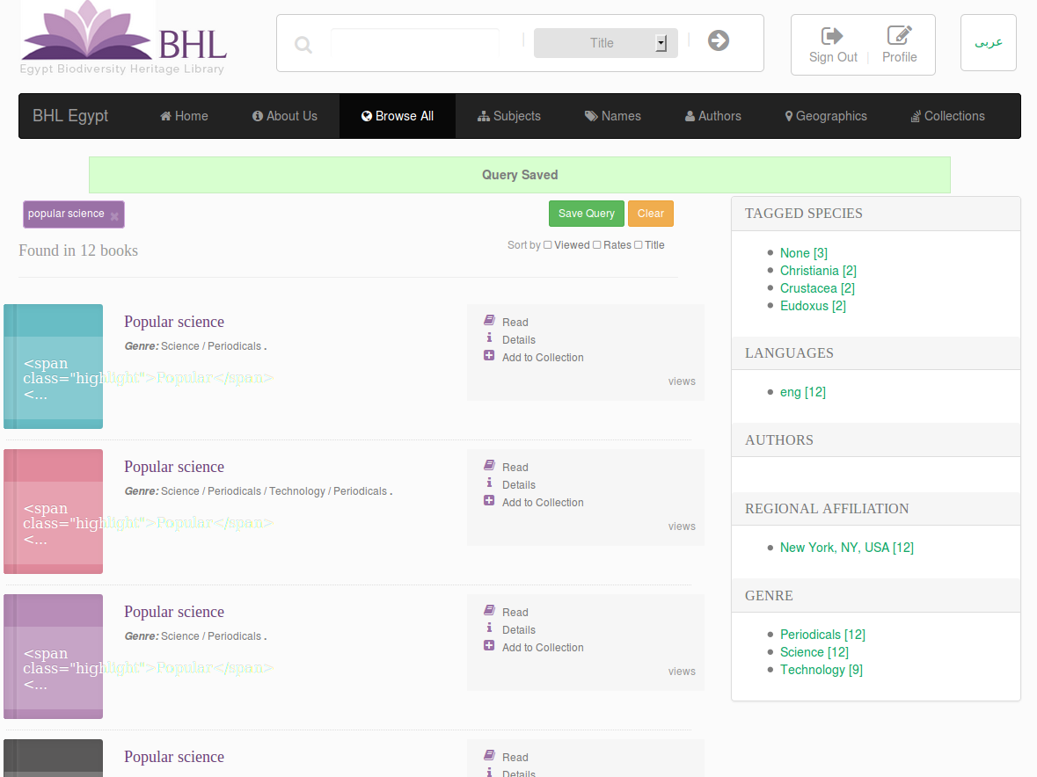

- Create collection
User can create collection of books.
The following steps describe how user can create a new collection:
- user should login first
- visit browse all page
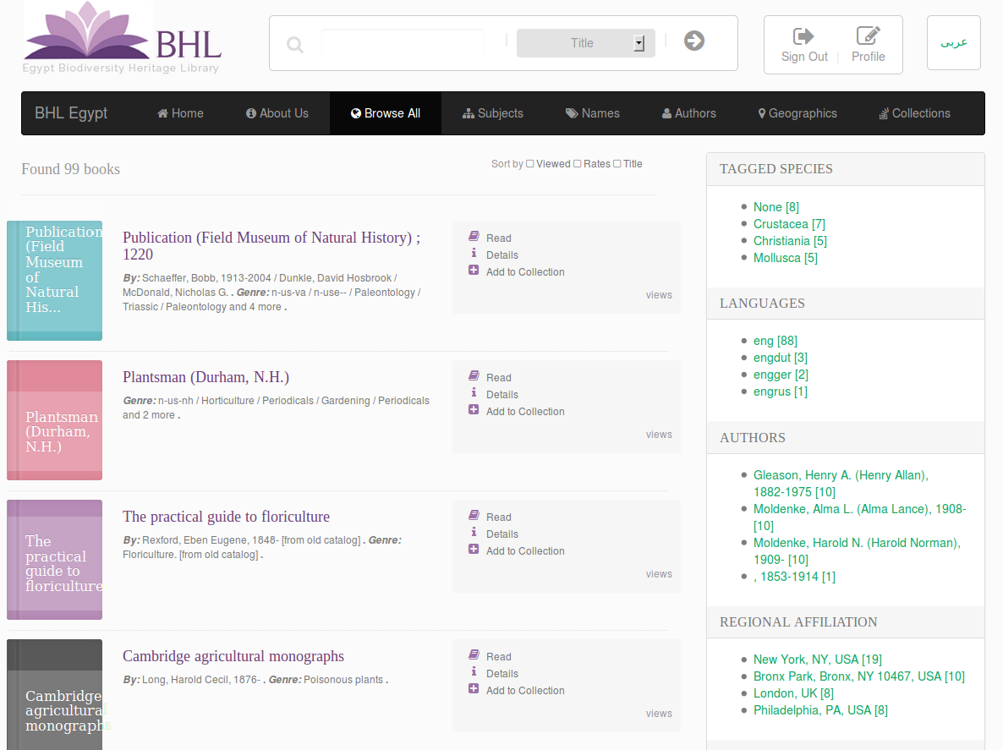

- click add to collection button for any book (e.g: first book)
- in the popup: select create new collection
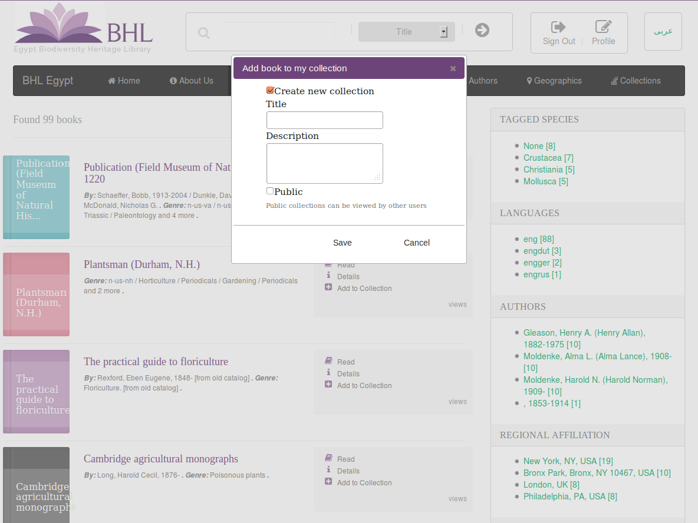
- fill fields of the new collection (title and description of the new collection, and also the visibility flag of the new collection)

- Edit collection
User can edit collection information (e.g: collection title).
Steps
- user should login first
- visit user profile page and click collections tab
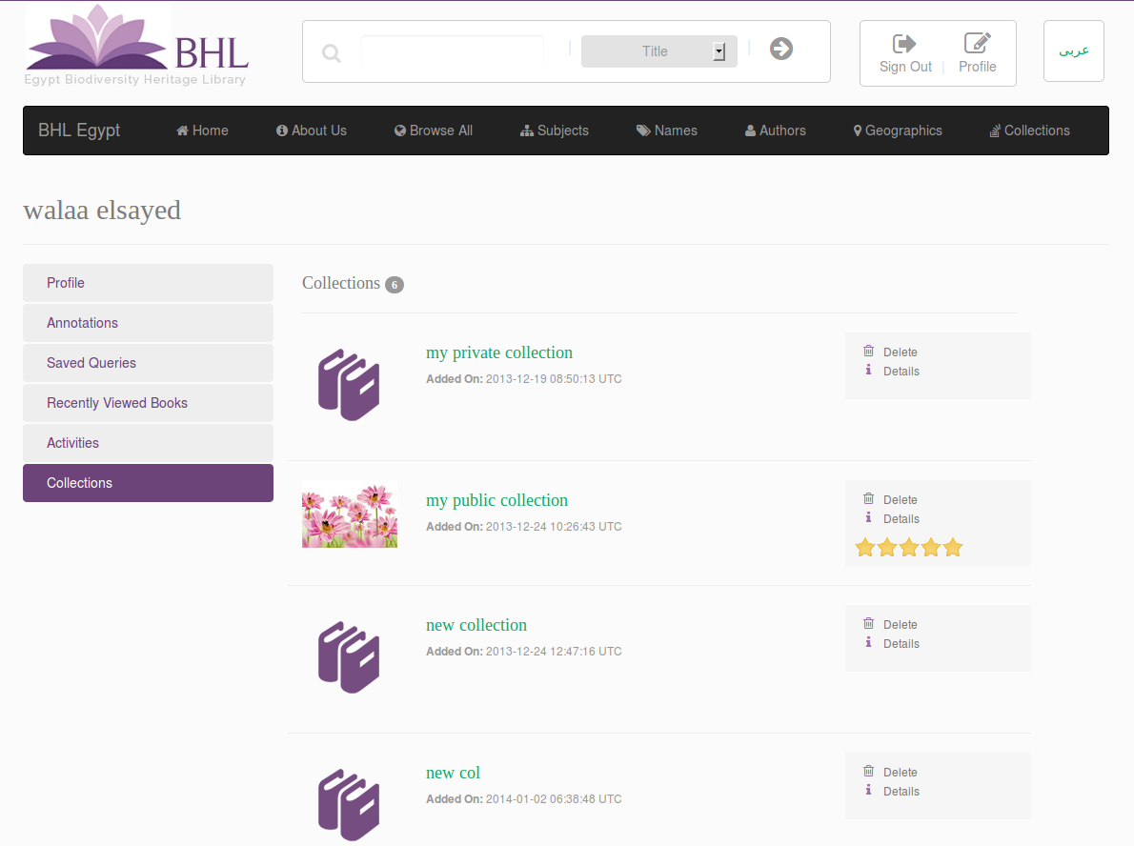
- click details button for any collection(e.g: first collection)
- click edit collection button
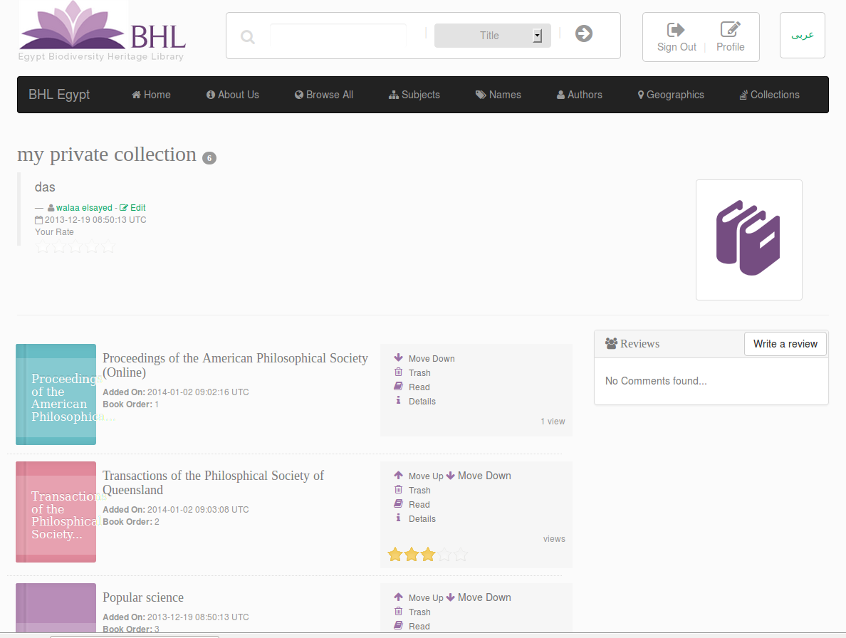
- using the following screen user can edit information of his collection and also can upload photo for his collection
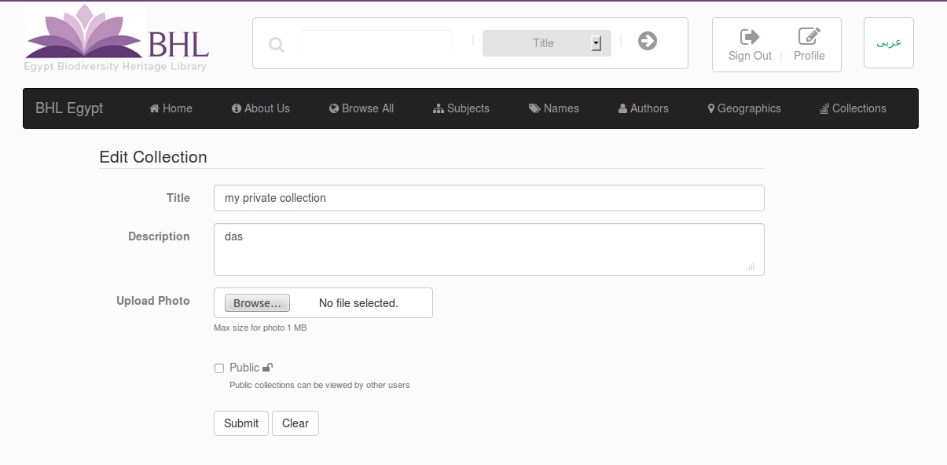

- Add book to collection
User can add many books to a collection.
Steps
- user should login first
- visit browse all page
- click add to collection button for any book (e.g: first book)
- in the popup: choose either to add book to exiting collection or create a new collection
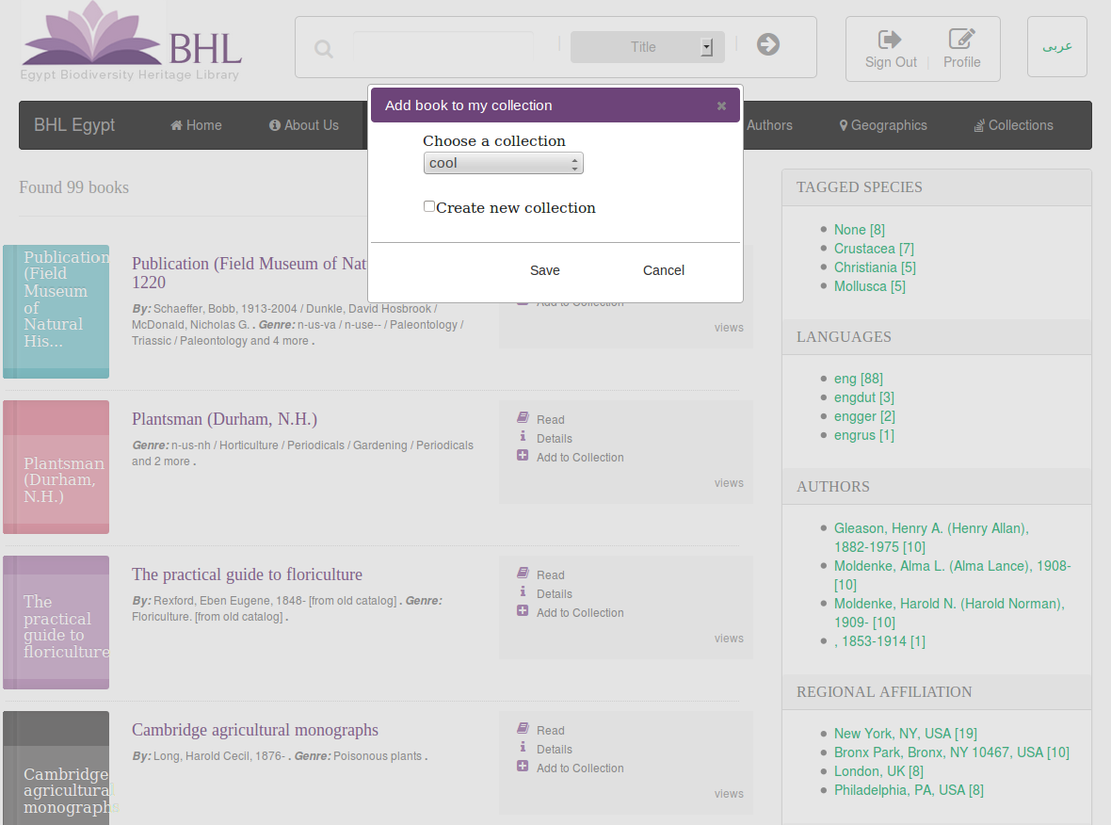
- Manage books in collection
User can add books to collection, delete books from collection and change books order in collection
Steps
- user should login first
- visit user profile page and click collections tab
- click details button for any collection(e.g: first collection)
- scroll down to see books in this collection
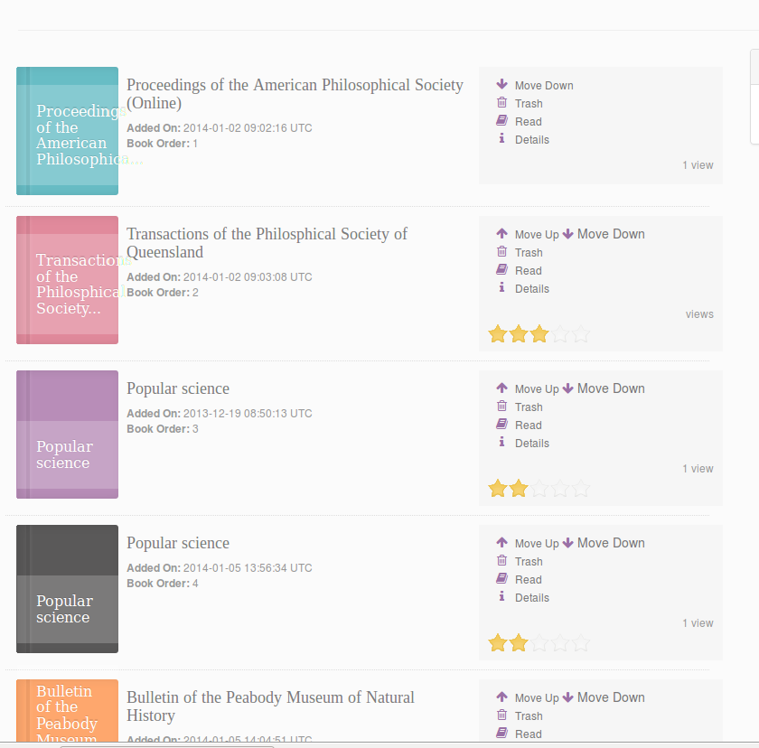
- user can change the default order of each book included in one of his collections by clicking (move up button: to increase book order or clicking on move down button to decrease book order) .

- Write comment on book
User can comment on any book.
Steps
- user should login first
- visit browse all page
- open any book (e.g: first book)
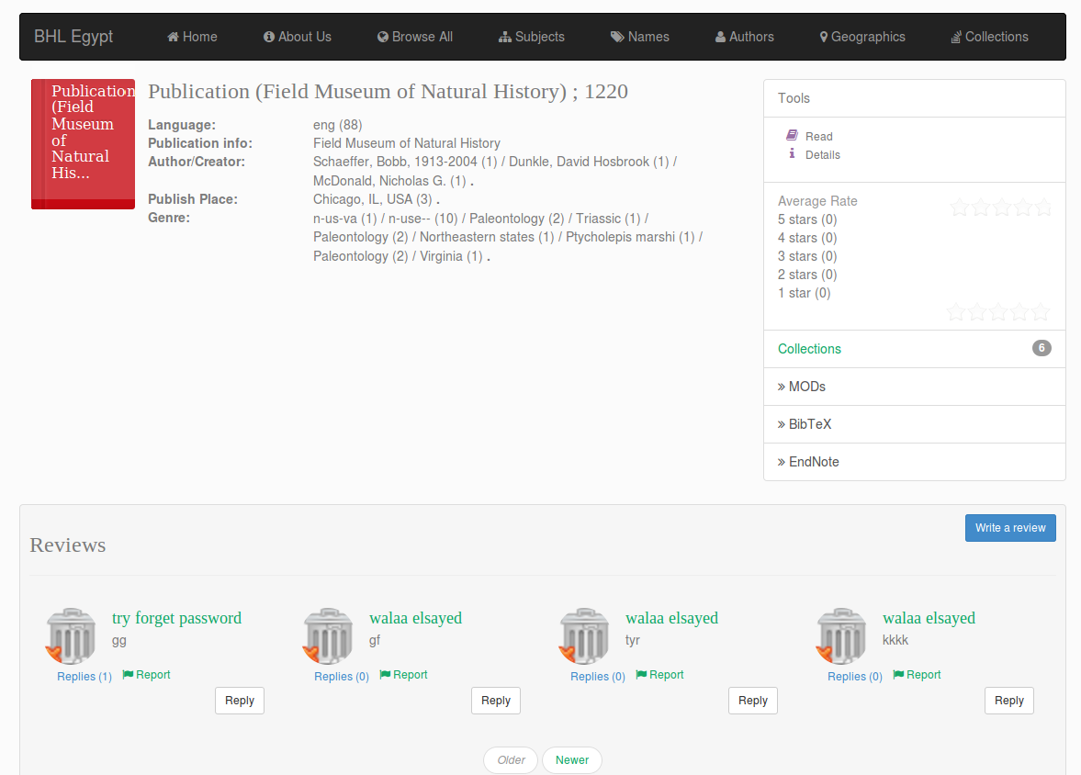
- click write review button
- put your comment and click post button
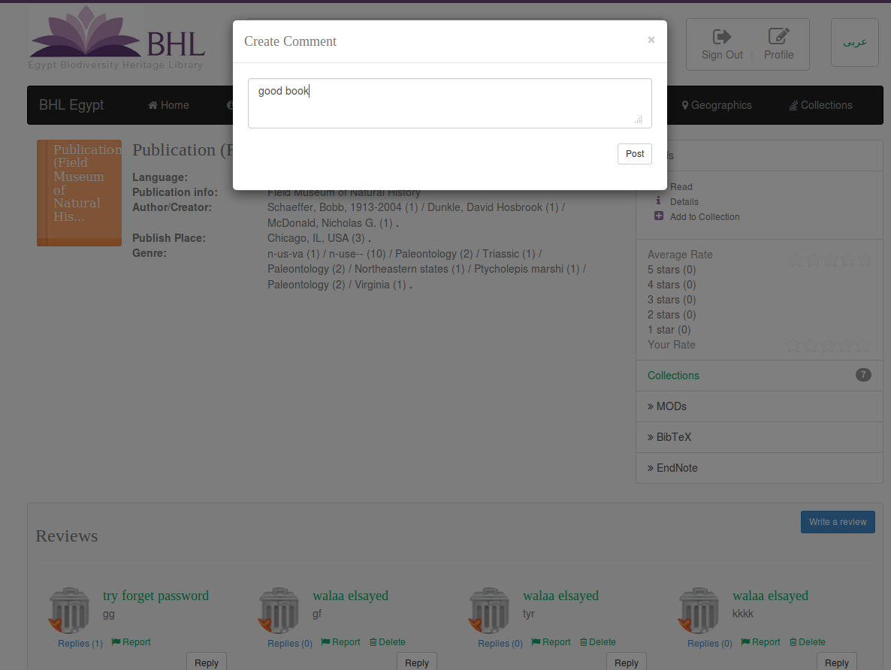
- Write comment on collection
User can comment on public collection owned by other users and also can comment on his private and public collections.
Steps
- user should login first
- visit collections page
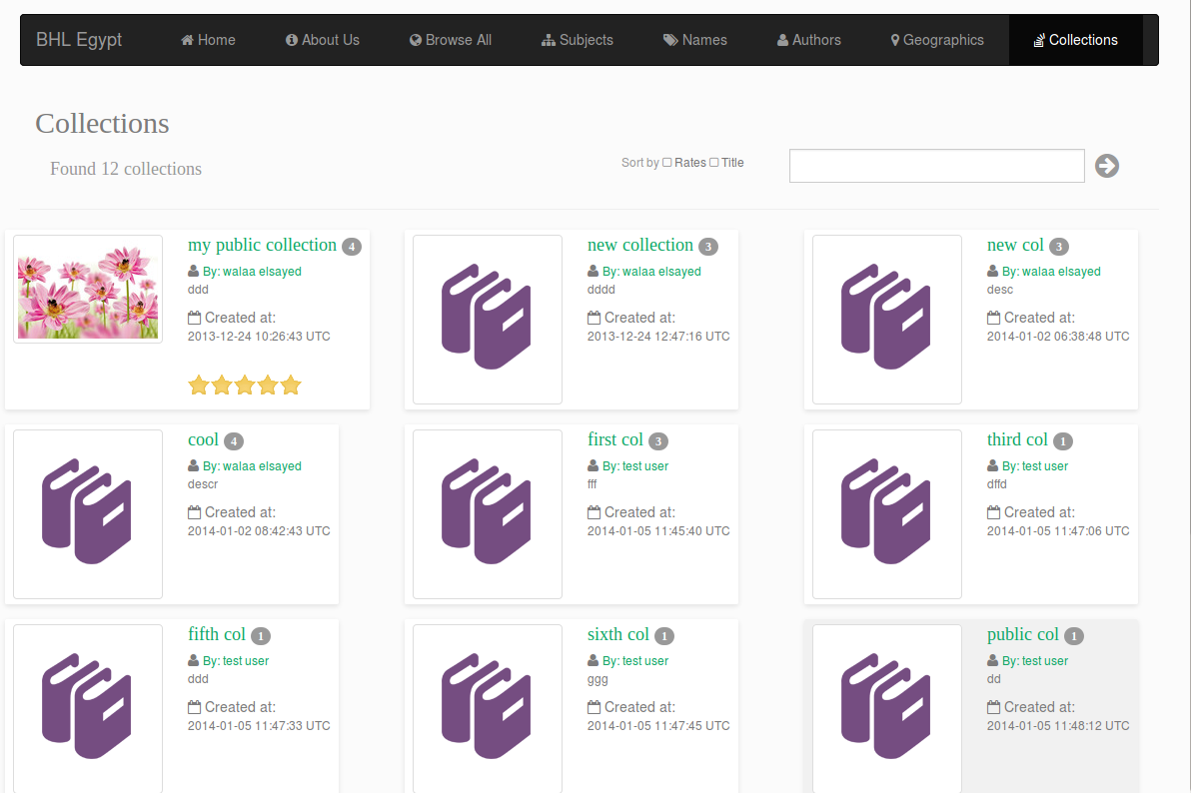
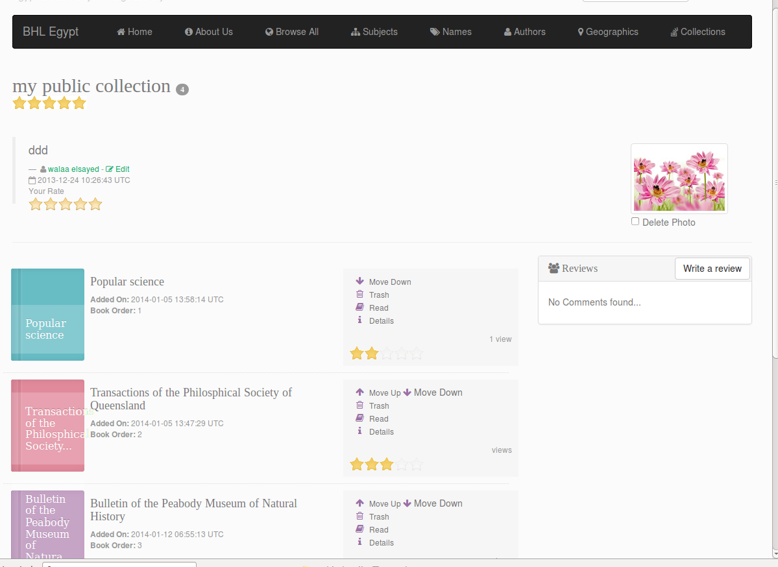
- open any collection(e.g: first collection) click on write review button
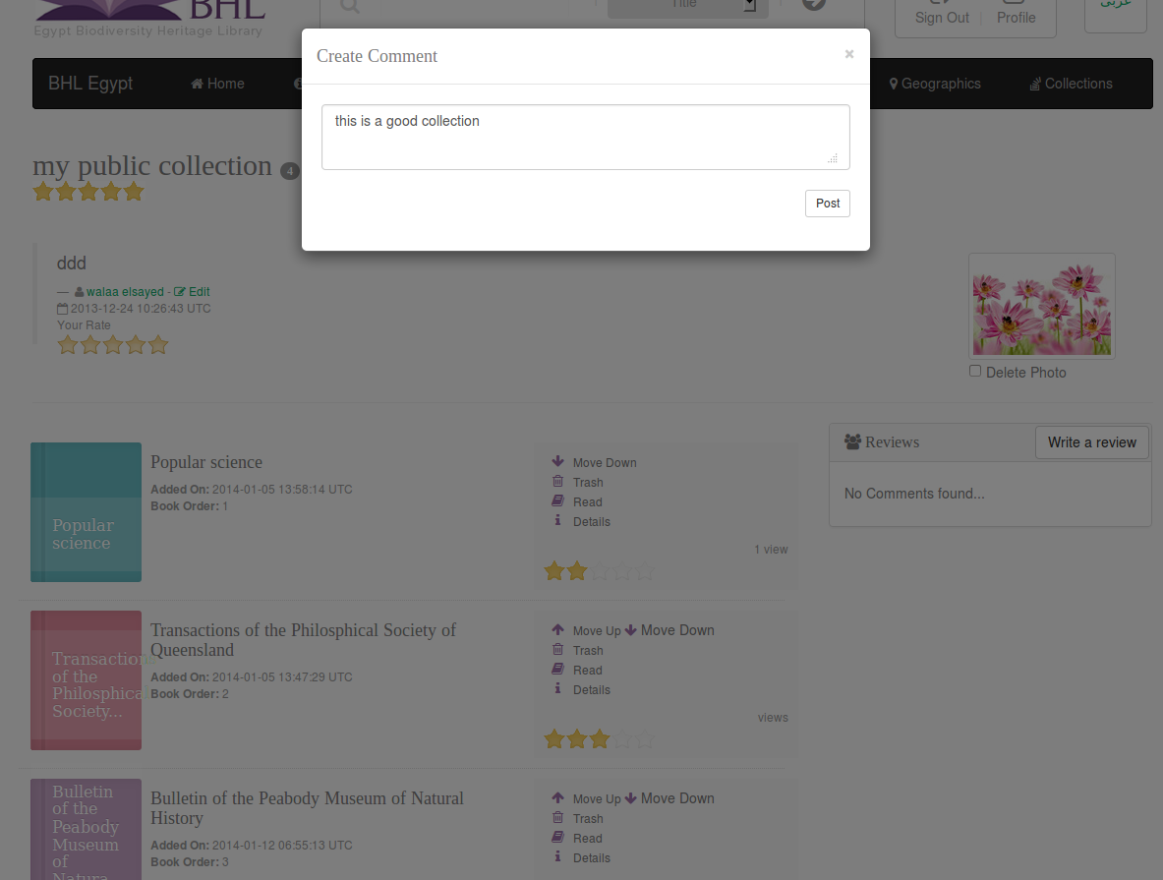
- write your comment on this collection then click post button

- Rate book
User can rate any book.
Steps
- user should login first
- visit browse all page
- open any book (e.g: first book)
- put your rate on this book

- Rate collection
User can rate any public collection owned by other users and also can rate his private and public collections.
Steps
- visit collections page
- open any collection(e.g: first collection)
- put your rate on this collection.

- Search for collections
User can search for collections (public collections) by title
- Sort collections
User can sort collections (public collections) by two options: rate, title.

